**Bharati College**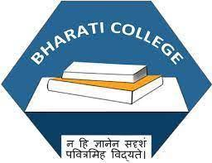

**(University of Delhi)**

Janak Puri, Delhi- 100058

[www.bharaticollege.du.ac.](http://www.bharaticollege.du.ac.)in

**Lesson Plan (CORE, Semester IV, January To May,2023)**

|  |  |  |  |  |  |
| --- | --- | --- | --- | --- | --- |
| **Name of Teacher** | DR Kalpana Kataria | | **Department** | | Commerce |
| **Course** | B.Com | | **Semester** | | IV |
| **Paper** | E-Commerce-Lab | | **Academic Year** | | 2022-23 |
| **Learning Objectives** | | | | | |
| To enable the students to become competent to understand the mechanism for excelling in e-commerce-based employments and self-employment opportunities. | | | | | |
| **Learning Outcomes** | | | | | |
| 1. Understanding of the development of Website designing | | | | | |
| **Lesson Plan** | | | | | |
| **Week No.** | | **Theme/Curriculum** | | **Any Additional Information** | |
| Week 1-6 | | * Basic Structure of HTML * Creation of Web Page * Formatting * Lists | | Allocation of Assignment I (Last Date 24th  March 2023) | |
| Week 8 –15 | | * Tables * Forms * Frames | | Allocation of Assignment II (Last Date 30th  April 2023) | |
| **Resources**  1. Dr R.S. Bhardwaj and Ms Bhamini Garg, E-Commerce, 2nd Edition, Galgotia Publishing Company  2. HTML Moocs with IIT Bombay  3. You tube lecture series | | | | | |
| **Online Resources (If Any)** | |  | | | |
| **Assignment and Class Test Schedule for Semester** | |  | | | |