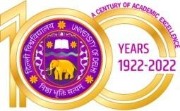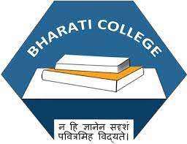Bharati College

**(University of Delhi)**

Janak Puri, Delhi- 100058

[www.bharaticollege.du.ac.](http://www.bharaticollege.du.ac.)in

Lesson Plan (SEC, Semester 3, July to Dec 2022)

|  |  |  |  |  |  |
| --- | --- | --- | --- | --- | --- |
| **Name of Teacher** | Kangkana Roy | | **Department** | | __English___________ |
| **Course** | BA ENG(H) | | **Semester** | | 3 |
| **Paper** | LIT. IN CROSS CULTURAL ENCOUNTERS | | **Academic Year** | | 2022 |
| **Learning Objectives** | | | | | |
| 1. **To acquaint and engage students to think critically about various issues in the world.** 2. **Students will gain entry into issues like caste, gender, race, war/violence through literature.** | | | | | |
| **Learning Outcomes** | | | | | |
| This course helps students to think aloud and question various common place issues found in the society like discriminations based on race, caste, gender and other issues like Violence and war. The literary pieces are structured in such a way that students will not only get introduced to these issues but will also engage with it by locating it within their own lived experience. It will enable students to engage and think critically. | | | | | |
| **Lesson Plan** | | | | | |
| **Week No.** | | **Theme/Curriculum** | | **Any Additional Information** | |
| 1-12 | | * Caste/Class | |  | |
|  | | * Gender | |  | |
|  | | * Race * Violence and War * Living in Globalised World | |  | |
| **References**   1. Selections from *The Individual and Society: Essays Stories and Poems* edited by Vinay Sood et al. for The Department of English University of Delhi New Delhi Pearson 2006.   **Additional Resources**  1. | | | | | |
| **Online Resources (If Any)** | |  | | | |
| **Assignment and Class Test Schedule for Semester** | | Internal Assessment: 25 Marks  Students in this course have primarily three modes of assessment:   1. Written assignment 2. Presentation 3. Class Test. | | | |