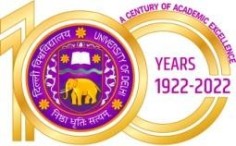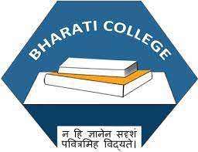Bharati College

**(University of Delhi)**

Janak Puri, Delhi- 100058

[www.bharaticollege.du.ac.](http://www.bharaticollege.du.ac.)in

Lesson Plan (CORE, Semester 4, JAN- MAY 2023)

|  |  |  |  |  |  |
| --- | --- | --- | --- | --- | --- |
| **Name of Teacher** | Kangkana Roy | | **Department** | | _______English ________ |
| **Course** | B.A ENG (H) | | **Semester** | | 4 |
| **Paper** | INTRODUCTION TO CREATIVE WIRITNG FOR MEDIA | | **Academic Year** | | 2023 |
| **Learning Objectives** | | | | | |
| 1. Introduce students to the complex phenomena of Creativity and that it has a relationship with social change. 2. Introduce students to language varieties and the nuances of language usage. 3. Introduce students to different forms of media writing, how to write critically and develop skills of proofreading. | | | | | |
| **Learning Outcomes** | | | | | |
| Students will be able to conceptualize the varied phenomena of creative writing by not only studying it theoretically but also applying practical skills of application through in-class writing sessions and discussions. | | | | | |
| **Lesson Plan** | | | | | |
| **Week No.** | | **Theme/Curriculum** | | **Any Additional Information** | |
| 1-12 | | * Unit 1 and 2 will deal with the theoretical conceptualization and understanding of the concept of Creative writing and the nuances of what it entails. | |  | |
|  | | * Unit 3 and 4 will be an introduction to the hands on practical writing sessions into the application of the creativity in creating content for media especially focused in the Print media forms as well as learning the art of writing, re-writing and proof reading. | |  | |
|  | |  | |  | |
| **References**  **Additional Resources**  1. | | | | | |
| **Online Resources (If Any)** | |  | | | |
| **Assignment and Class Test Schedule for Semester** | | **Internal Assessment marks out of 25 marks.** | | | |