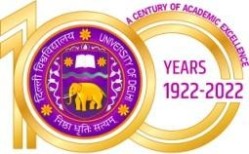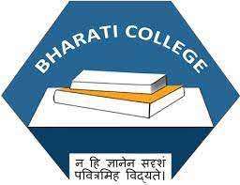Bharati College

**(University of Delhi)**

Janak Puri, Delhi- 100058

[www.bharaticollege.du.ac.](http://www.bharaticollege.du.ac.)in

Lesson Plan (CORE, 26th August to 12th December 2022)

|  |  |  |  |  |  |
| --- | --- | --- | --- | --- | --- |
| **Name of Teacher** | Dr. Rakhi Jain | | **Department** | | English |
| **Course** | B. A. Program | | **Semester** | | iii |
| **Paper** | SEC-Creative Writing for Media | | **Academic Year** | | 2022-23 |
| **Learning Objectives** | | | | | |
| This course introduces students to the concepts of ̳creativity‘ in general and ̳creative writing‘ in particular. This paper focuses especially on writing for the media, ranging from newspapers and magazines to emerging new media forms. After being given a foundation in the theoretical aspects of writing for the media, real life examples will provide practical exposure. This course will encourage students to be active readers and writers, who will engage with contemporary issues in a well informed manner. This course will be of interest to those students who wish to pursue creative writing, especially those who wish to work in the media. | | | | | |
| **Learning Outcomes** | | | | | |
| * Introduces students to the idea that creativity is a complex and varied phenomenon that has an important relationship with social change * Familiarizes students with ideas about language varieties and the nuances of language usage * Introduces students to the language and types of media writing across forms and genres and * Encourage students to revise their work critically and inculcate the skills of proofreading. | | | | | |
| **Lesson Plan** | | | | | |
| **Week No.** | | **Theme/Curriculum** | | **Any Additional Information** | |
| Week 1-6 | | Unit 1  What is Creative Writing?  a) Defining and Measuring Creativity b) Inspiration and Agency Creativity and Resistance  c) What is Creative Writing? Can it be taught? d) The importance of Reading  Unit 2  The Art and Craft of Creative Writing  a) Styles and Registers b) Formal and Informal Usage c) Language Varieties Language and Gender d) Disordered Language e) Word order Tense and Time Grammatical differences | | Reading in the classroom  A discussion on different regional and social dialect  Standard and non standard language | |
| Week 7-10 | | Unit 3  Writing for the Media  a) Introduction to Writing for the Media  b) Print Media c) Broadcast Media d) New Media  e) Advertising and Types of Advertisements | | Prepare advertisement on posters and flyers | |
| Week 11-14 | | Unit 4  Revising Rewriting and Proof Reading  a) Revising b) Rewriting c) Proof reading and proof-reading marks | |  | |
| **References**  Creative Writing: A Beginners’, Manual by Anjana Neira Dev et al. For The Department of English, University of Delhi (New Delhi: Pearson, 2008). | | | | | |
| **Online Resources (If Any)** | | none | | | |
| **Assignment and Class Test Schedule for Semester** | | Assignment 1 on varieties of language in 2nd week of September and submission by 30th September  Class test on Preparing an advertisement on social media 25th November | | | |