**Bharati College**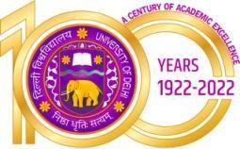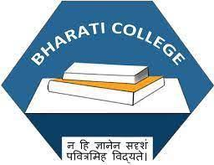

**(University of Delhi)**

Janak Puri, Delhi- 100058

[www.bharaticollege.du.ac.](http://www.bharaticollege.du.ac.)in

**Lesson Plan (CORE, Semester I, July to November2022)**

| **Name of Teacher** | Swati Bawa Sawhney | | **Department** | | Human Development and Family Empowerment |
| --- | --- | --- | --- | --- | --- |
| **Course** | B.A Prog | | **Semester** | | I (Minor) |
| **Paper** | Principles of Child Development | | **Academic Year** | | 2022 |
| **Learning Objectives** | | | | | |
| * To familiarize students with the concept of child development as a field of study. * To introduce students with various methods of child study * To create an understanding of prenatal development | | | | | |
| **Learning Outcomes** | | | | | |
| * Get familiarized with the concept of child development as a field of study. * Develop an understanding of prenatal development. * Learn about the basics of techniques of data collection. | | | | | |
| **Lesson Plan** | | | | | |
| **Week No.** | | **Theme/Curriculum** | | **Any Additional Information** | |
| Week 1 -Week 4 | | **Unit I- Introduction to Human Development**   * Definition, Scope and importance of child development as a field of study * Historical foundation of child development | | Allocation of Assignment I (Last Date 20th  September 2022) | |
| Week 5 -Week 9 | | **Unit II- Introduction to methods of Child Study**   * Observation * Interview * Questionnaire * Case study | | Test Scheduled | |
| Week 10 – Week 15 | | **UNIT III: Aspects of development**   * Principles of Development * Developmental Norms | | Allocation of Assignment II | |
| Week 15 – Week 20 | | **UNIT IV: Prenatal Development**   * Stages of prenatal development * Factors affecting prenatal development | |  | |
| **References**   * Berk, L. E. (2013). Child development (9th edition). New Delhi: Prentice Hall. * Colley, D. and Cooper, P. (Eds.) (2017). Attachment and emotional development in the classroom. Oxford City: Jessica Kingley Publishers * Verma, P., Srivastava, D. N. and Singh, A. (1996). Bal manovigyan and bal vikas. Agra: Agrawal Publication. * Singh, A. (2015). Foundation of human development: a lifespan approach. Hyderabad: Orient Longman.   **Additional Resources**   * Bee, H. L. (2011). The developing child. London: Pearson. * Papilla, D.E., Olds, S. W. and Feldman, R. D. (2004). Human development. New York: Mcgraw Hill. * Singh, A. (2015). Foundation of human development: a lifespan approach. Hyderabad: Orient Longman. * Singh, V. (2007). Bal vikas avam bal manovigyan. Jaipur: Panchsheel Prakashan. | | | | | |
| **Online Resources (If Any)** | |  | | | |
| **Assignment and Class Test Schedule for Semester** | | Link the assignment and Test (optional) | | | |