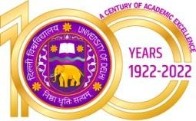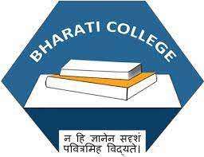Bharati College

**(University of Delhi)**

Janak Puri, Delhi- 100058

[www.bharaticollege.du.ac.](http://www.bharaticollege.du.ac.)in

Lesson Plan (SEC, Semester IV, January to June2023)

|  |  |  |  |  |  |
| --- | --- | --- | --- | --- | --- |
| **Name of Teacher** | Dr. Mithilesh Kumar Mishra | | **Department** | | History_____ |
| **Course** | B. A. Programme | | **Semester** | | IV |
| **Paper** | Archives and Museum | | **Academic Year** | | 2022-23 |
| **Learning Objectives** | | | | | |
| The aim of this course is to make the students familiar with the structure and functioning of both, archives and museums in India. This subject will also be taught with a view to give an insight into the aspects of employability in these institutions | | | | | |
| **Learning Outcomes** | | | | | |
| Upon successful completion of course students will be able to:  • Examine these two repositories of history from close quarters.  • Contextualise how the heritage is preserved and kept alive here and the difficulties faced in the process.  • Demonstrate the way in which museums are organised and managed.  • Examine the considerations which govern the way exhibitions in museums are managed.  • Assessment will be based on assignments and projects involving visits to the archives and museum, which is an essential component of this course | | | | | |
| **Lesson Plan** | | | | | |
| **Week No.** | | **Theme/Curriculum** | | **Any Additional Information** | |
| 4 Weeks Approx | | Definition of Archives and Museum: types - digital, virtual, crafts, media; difference between archives, museum and library | |  | |
| 4 Weeks Approx | | History of development of archives and museums in India with one case study each | |  | |
| 4 Weeks Approx | | Collection, documentation, preservation | |  | |
| 4 Weeks Approx | | Museum presentation and exhibition | |  | |
| **References**  Ambrose, Timothy & Crispin Paine. (1993). Museum Basics. London: Routledge.  • Choudhary, R. D. (1988). Museums of India and their Maladies. Calcutta: Agam Prakashan.  • Mathur, Saloni. India by Design: Colonial History and Cultural Display. Berkeley: University of California.  • Nair, S. N. (2011). Bio-Deterioration of Museum Materials. Calcutta: Agam Prakashan.  • Sengupta, S. (2004). Experiencing History through Archives. Delhi: Munshiram Manoharlal.  **Additional Resources**  1. | | | | | |
| **Online Resources (If Any)** | |  | | | |
| **Assignment and Class Test Schedule for Semester** | | Link the assignment and Test (optional) | | | |